# Chapter 1

# THE PROBLEM AND ITS SETTING

## Background of the Study

Barangay is the basic political unit that serves as the primary planning and implementing unit of the programs, projects and activities of the government as stated by the local government. Barangay officials are responsible to formulate measures, maintain cleanliness and beautification and maintain barangay-owned properties and infrastructures. (Lorenzo, et al., 2019)

Barangay officials overburdened by queries and needs of the community and rapid growth of cases of COVID. Manual transactions like it used to before can seem to be a drawback on their duties. Barangay is aspiring to adjust technical ways in achieving accountabilities to make a change in the lives of individuals. It means replacing human efforts with machines to keep track of the advances of technology. The researchers will conduct a study about Barangay using manual processes. It is tedious or labor-intensive in terms of recording that may cause inconvenience.

Stated on a website called Rubrik (n.d.), Data is one of the most important assets every business or system has; keeping the saved information always protected and available is one of the important features a system should have. Backing up files and data is necessary to avoid problems such as data loss, prevention from malicious attacks such as phishing and ransomware, and repetition of data.

Data has the potential to provide a lot of value, to unlock this value, it needs the analytic component. Data analytics refers to the procedure of observing datasets to draw assumptions about the data they contain. It enables raw data to uncover patterns to extract valuable insights from it. Some benefits from data analytics include improved decision making, more insights to what your user service needs, and more efficient operation (Lotame, 2019).

The term crowdsourcing according to Samonte et.al (2019) is a mix of two words that is crowd and outsourcing. It is a type of a sourcing method, which gathers information and contributions from the users of the internet to receive ideas, and helpful services that will be needed. Another most common transaction with barangay is processing a document for a business or individual, and requesting these documents will use some resources of the barangay so it could have a cost.

One of the best and most convenient ways to be on top of finances is to make use of electronic payment. The benefits of electronic payment are its convenience and having the capability to track your spending. With the obvious demand for more outlets and resources for electronic payment, there is no other way to get around but for our country’s payment system to adapt to it (Padillio, 2019).

The researchers aim to develop the Barangay and Residents’ Information System that can prevent data loss and lessen the workload of barangay officials. Next is to make a solution for BaRIS to avoid and prevent malicious attacks that can harm the system and to keep the data safe, because these data can be used by people with bad intentions and may endanger the lives of the people in the barangay. Furthermore, create a mobile application that has a crowdsourcing functionality which is about processing complaints by automating the process of manual filing, handling, and creating data analysis. This type of recording for complaints around the barangay will be helpful to the barangay if implemented since it fastens the processing of complaints and can be solved faster.

Lastly, data analytics will be used to raw data to get valuable insights about the barangay. After this analysis, the barangay can better understand the problems of their community and will come up with an effective solution easier.

## Objectives of the Study

The general objective of the study is to develop a Progressive Web Application for Barangay and Residents' Information System

Specifically, the study aims to:

1. To design a Progressive Web Application for Barangay and Residents' Information System with the following features:
   1. Online application of barangay clearance, certificate of indigency, residency, cedula, and business permit. Online payment and via Kiosk or 7 eleven.
   2. Delivery via email of document with password together with the receipt or delivery via courier
   3. Profiling system
   4. Recording of blotter, complaints, health and emergency services and cases
   5. Post barangay programs and announcements.
   6. Centralized barangay information.
   7. Backup, Audit Trail, and Archiving.
   8. Generate reports and organize data through Data Analytics.
2. To create the proposed application by using Hypertext Processor (PHP) and JavaScript, ReactJS as an open-source library for web and React Native for mobile development. In addition, the researchers will use MongoDB for the database. Lastly, Visual Studio Code will be the preferred IDE.
3. To test and further improve the system’s accuracy and portability of both web and android apps to reach the expectations and requirements.
4. To evaluate the performance of the proposed web and mobile application based on ISO 25010 criteria for quality software which are Functionality, Suitability, Performance Efficiency, Compatibility, Usability, Reliability, Security, Maintainability, and Portability.

## Scope and Limitations of the Study

The study focuses on developing a progressive web application for barangay and residents' information systems. The proposed system will be used by a specific barangay which is Barangay Canlubang located in Calamba Laguna. Features like online document application and payment for users need to have a certain level of authenticity to be able use this action. The system also offers registration of a certain program of a barangay such as daycare enrollment and health care services of a barangay. The website can be installed on any mobile phone from a browser.

The proposed system will be developed by using Hypertext Preprocessor (PHP) and JavaScript using ReactJS for web development. For mobile application development, the researcher will use React Native. Open-source web technologies such as HTML, JavaScript and CSS for web pages and web applications. The researcher will use Visual Studio Code as the Integrated Development Environment (IDE). MongoDB is the database management system that will be used by the system for storing, retrieving and analyzing data.

The proposed system will accommodate cross-platform devices like IOS and android for mobile phones while for computer devices, the minimum operating system version will be windows 7 and the recommended is windows 10. The system will be evaluated by a certain number of guests, residents, and barangay officials from the selected barangays using features such as online document application and payment, crime and emergency report, and other features of the system.

The proposed system will only be accessible for devices mentioned above that have access with internet connection, storage, and camera and other permission needed by the system.

## Significance of the Study

## The study will benefit not only the barangays but also the nation as a whole. Local government and enhance the delivery of basic services to the community. With the system, the collection of information will be much easier thus; improvement in the services coming from the local government will be more effcient. Effectively finding ways to solve problems coming from the collected data that was analyzed by the system and the proper implementation of this solution with the help of the said system will surely be a great help to our country and its citizens.

# Chapter 2

**CONCEPTUAL FRAMEWORK**

This chapter presents a review of related literature, articles, and journals that support the framework of the study. This also covers the conceptual model of the study and operational definitions of terms.

## *Barangay*

Under the 1991 Local Government Code, the barangay was structured and is presently functioning as another level of government, the lowest level. It is the lowest level but it is not that simple. It has an elected Punong Barangay, a Sangguniang Barangay consisting of seven elected members and the Sangguniang Kabataan Chairman, and a separate appointive secretary and an appointive treasurer, altogether 11 barangay officials. In addition, each barangay has to organize a Lupon ng Tagapamayapa consisting of a Chairman and 10 to 20 members. In addition, for each dispute in the barangay, a Pangkat ng Tagapagkasundo, consisting of three members, has to be organized. The barangay can also organize local tanods.

According to DILG Local Government Code of the Philippines Book III, the role of the barangay is to serve, plan, and implement policies, plans, programs, projects, activities in the community, and as a forum wherein the collective views of the people may be expressed, crystallized and considered, and where disputes may be amicably settled.

A barangay has several powers, roles and duties, and functions. Among all, the Punong Barangay is the highest, enforces all laws and ordinances; maintain public order; ensure the delivery of basic services; enforce laws and regulations relating to pollution control and protection of the environment; adopt measures to prevent and control the proliferation of squatters; and adopt measures to prevent and eradicate drug abuse, child abuse, and juvenile delinquency. The Sangguniang Barangay can enact ordinances; levy taxes and other revenue measures; provide for construction and maintenance of barangay facilities and other public works; regulate use of public facilities, including waterworks (Business World, 2018).

Barangay is the basic political unit as stated by the local government. According to the Philippine Statistics Authority, one can consider an urban barangay if a barangay has a population size of 5,000 or more, if a barangay has at least one establishment with a minimum of 100 employees, or if a barangay has five or more establishments with a minimum of 10 employees, and five or more facilities. Note that if the facility is not present in the barangay, presence of facilities within the two-kilometer radius from the barangay hall is considered.

One of the features of the Barangay Residents Information System is the contactless acquiring of such requirements; barangay clearance, business permit, certificate of indigency and residency. The traditional way of getting these documents requires physical appearance in the barangay.

Barangay clearance is a government-issued document in the Philippines. Residents use it to certify that he/she is a person with good morals and a law-abiding citizen of a certain barangay. According to Montealegre (2021), it is commonly used to process legal and financial transactions in the locality. The person is required to acquire and prepare the following requirements to obtain barangay clearance:

1. Recent Cedula.
2. Application form from barangay; cash for fee.

Business permit is another document a resident can get in a barangay. Business permit is a certification of legitimacy on a certain business. Having this document is a license to operate in the city or municipality where it is registered. According to Pututan-procedure City Government of Muntinlupa, the person or group is required to acquire and prepare the following to attain business permit:

1. DTI permit.
2. Certificate of Incorporation from Security and Exchange Commission.
3. Certification from Homeowners/Village Associations.
4. Application form from barangay; cash for fee.

Certificate of Indigency and Residency is a document that is required by the Philippine government or a private institution as proof of an individual's financial situation. The certificate is required to avail of government services; educational scholarships or medical assistance. The person in need is required to acquire and prepare the following to attain certificate of indigency and residency:

1. Barangay certification.
2. Certificate of no property.
3. Certificate of no business.
4. Certificate of tax exemption from BIR.
5. Assessment report from city social welfare and development (CSWD).

***Information Management***

The barangay has a lot of information to handle. It includes the information of the people in the barangay that can be acquired through census. It can also be the data about the yearly budget of the barangay with its liquidation. However, recording in a paper is very laborious and it will take a lot of space in storing the recorded data when the time passes. Having an information management system in one barangay can lead to hassle-free workspace.

Information Management is to collect and manage data from more than one source and distribute this data to one or more target groups. This may affect those who are involved in or have rights to this data. Management means organizing and controlling the arrangement, handling, and provision of data (AIIM, 2019). Information management is usually the concept of a business data structure in which an association creates, owns, and manages a variety of data. The data can be in the form of hard-copy data or digital databases. As stated by Regional Safe Space Network (2021), it has four stages to complete one cycle. It is the collecting, storing, analyzing, and sharing. Information management is concerned with the equal and control of an organization's control over data resources. Information management is usually attained through specially developed information management structures and support for business procedures and strategies. In addition, Information management concentrates on how this information is disseminated and delivered to different receivers, with different computing technology such as personal and organizational websites, CPUs, servers, applications and mobile devices (Techopedia, 2017). The supervisory principles that approve data to be accessible to the right individuals at the correct period and the structural and societal perspectives in which data occurs (iSchool, 2019).

According to Zwass (2020), information management is used worldwide such as in transportation structure, network-based data structures have been a variable in the development of global business and partnerships. A connection between the organization of data frameworks and usefulness has been displayed in various businesses when these frameworks supplement other corporate assets. The advancement of the Internet-based system joined by the minimal expense of equipment and broadcast communications, the accessibility of open-source programming, and the mass worldwide admittance to cell phones has prompted a upsurge of pioneering movement and the development to unmistakable quality and huge market worth of various firms dependent on new plans of action. Among the models are electronic sale firms, internet searcher firms, electronic shopping centers, interpersonal organization stages, and web based game organizations.

Because of the tremendous open doors for moving work with information, data, and information in electronic structure to the most financially perceptive setting, a worldwide rearrangement of work has been occurring. In terms of income, having better information management will decrease the cost of information processing that will result in saving money. Related to that, since it decreases the cost, it can be used for other expenses such as investing in information management that can cause the return of investment faster. Lastly, the most obvious and helpful benefits of having good information management is increased efficiency, improved effectiveness, better performance, and it can sustain responsiveness (Chartered Institute of Library and Information Professionals, 2020).

Productive [information management](https://www.apm.org.uk/resources/glossary/) allows development sides to spend their time, resources and skill efficiently to make choices and to achieve their roles. Describing information management procedures and duties is a main set-up action because plan specialists have no structure techniques, and carry out processes dependent on them. It is at the core of business development, which is the reason such a lot of exertion and assets are siphoned into it creating effective data, the board frameworks, and qualified experts to assist with carrying out them. For organizations, further developing proficiency and acquiring an upper hand, implies expanding benefits (InterActive Pro 2021).

Almost all the transactions during the time of pandemic happen online. Users are sometimes fooled by fraudulent transactions. Since the proposed Barangay Information Management System will be able to provide necessary online, online payment will be applied. According to a website called Lyra (2021), the Electronic Payment system or Online Payment is a way for consumers to pay different services by using online electronic ways. Up to 80 percent of online consumers use cash on delivery as their way of payment was recorded. Furthermore, exactly six years ago with a percentage of 41% of the population on the internet only 1% percent are about payments that are done online but due to the pandemic, having to prevent physical contact made more Filipinos rely on digital cash rather than real cash (Devanesan, 2020).

One of the well-known digital payment methods being used by the majority of the citizens of the Philippines is GCash that can be installed on any smartphone or tablet device. It is a type of e-wallet that is similar to a physical real wallet where the user can store information online and can be used for a secure and convenient electronic transaction. It can be used to pay bills, bank transfers, sending money, lending load, and many more (Savillo & Ruaya, 2021). Moreover, applications such as Paymaya and Coins.ph are considered as an e-wallet that can be used for the system for digital banking, applications such as BDO and BPI mobile can be considered as well as credit card or debit card options.

***Figure 1***. Gcash main menu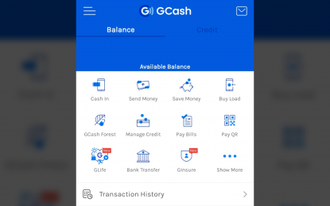

Having to apply e-payment on a system there are still some advantages and disadvantages of electronic payment systems. E-payment is known to be effective, efficient and very convenient to consumers. It can be easily accessed that can prevent time wasting and users are aware of their balance and transactions in real time (Wróbel-Konior, 2020). Some applications are also secure and safe to use, improving the experiences of consumers in terms of gaining personal information and has instant notification features for important alerts (Chuprina, 2021). However, one of the disadvantages of these applications is they gather important and personal data from users and would require internet connection (Wróbel-Konior, 2020).

Lack of knowledge in using these kinds of applications can also lead to some human errors that can harm the users’ data and experience. That is why having an Acceptable Use Policy or AUP can be an important part for information security policy. According to BioMelbourne Network (2020), it is a type of document that shows limitations and practices a certain user must agree upon in order to have access to the application or to the network. By having limits to the users, it can help the application or the internet to not only support the law but also to provide protection for users against cybersecurity threats. E-payment applications such as GCash have its own Acceptable Use Policy in order to help consumers to feel secure and to know the limitations of the application, some of it are the “do’s and don'ts”, certain agreements, awareness that can inform individuals.

Nowadays, information management and electronic payment can run on many platforms. It can be on a mobile application or browser of a laptop. With its versatility, it decreases the workload of a person. Just think how easily you can have a transaction anytime and anywhere with your device and internet and for one barangay it is very accommodating.

## 

## *Web and Mobile platform*

The comfort and convenience of having an application on web and mobile platforms for the residents is a big help in making the transactions less hassle and efficient.

Different software needs to have a parallel hardware for it to work and vice versa, but with the fast development of technology in the present time this barrier seems to be getting smaller with the flow of time. Now different software applications can now run on different platforms like computers, smartphones, smart televisions, cameras, gps, etc., or what the people call it today is cross-platform development (Suria International Services, 2019). The technology, which is implemented using web and mobile platform tools, is proposed for modeling of gesture units of sign language, dynamic mapping between states of gesture units with a combination of gestures structures such as words or sentence (Amatya, S., et al., 2014).

With the cross-platform means, technology achieves the ability to run on multiple platforms without implementation for each platform. The quality of an app, or more accurately, the perceived quality of an app may be assessed from the reviews posted by real users of the app on app marketplaces such as Google Play and the Apple App Store. User reviews have been regarded as a reliable source in assessing the perceived quality of apps in multiple works from prior literature. (Mercado, I.T, et al., 2016)

According to Arun (2018), in the last few years, the concept of cross-platform mobile app development has been a hit. It allows the developer to write the code once and employ it across all platforms, which are Android, iOS or Windows. It is not difficult to see when a majority of the targeted audience is using the same platform. It is then easy to choose which platform to develop the app on. However, when the goal is to target a huge audience who could be using iPhone, Android, Windows Phone and others, the app would have to be made separately for the different platforms. This is where cross-platform development is advantageous. Especially today with all things technological, it cannot be very easy to implement but the benefits provide a better outlook on app development.

The continuous development of web and mobile technologies facilitates the creation of novel mobile applications. Today’s smartphones are equipped with a rich set of built-in sensors, e.g. positioning sensor, microphone, and camera (Zbick, J., et al., 2014).

Barangay transactions such as request and issuance of documents can be done through mobile applications. Since it is an everyday transaction, it is an advantage for the residents and barangay officials.

According to Teclogiq (2019), to ensure the visibility of an application in such a complex scenario, one must need to be very particular about the approach being followed for web and mobile platform development. To develop a successful web and mobile platform application there is a systematic approach that needs to be followed; define the objectives, lay out application’s functionality and features, choose the development tool, dedicate API Services for web and mobile platform applications, deal with multiple platforms and check for certain capabilities and behave differently based on their presence, and test if it passed the approval process to ensure it reaches the market.

Progressive Web Application is also a feasible solution for cross-platform mobile development. According to Tang (2021), Progressive web applications are applications that are websites or web pages, but can be seen and behave like local mobile apps for users. Progressive web applications use web technologies like HTML, CSS, and JavaScript to deliver a mobile- and app-like experience through web browsers, including Chrome, Firefox, and Safari. By using a progressive web app, residents can retain and reach out to different kinds of users and also give them the freedom to view content wherever and whenever they want.

## *Data Analytics*

To be able to apply the above-mentioned topics and ideas, data management systems should be integrated to the system with the addition of data analytics. From collection of data from the residents of the barangay, everyday transactions and crime reports. Keeping it organized and secure for the benefit of the barangay so they can optimize those collected data and turn it into information that will help them in their decision making while still following the policies of their organization. This process is called data analytics, helping the people to see patterns from data they collected, analyzing it, and showing proper representation to make it easier to understand.

According to M. C. Lucas-Estañ et al. (2018), to successfully fulfill the restrictions and variable requirements in terms of latency, dependability, and data rates expected by industrial applications, communications and data management must be designed on a flexible and dependable architecture, with special emphasis paid to time-critical automation. To achieve this goal, the authors propose the integration of heterogeneous communication technologies into a hierarchical communications and data management architecture, in which a central orchestrator, ensuring the system’s efficient global operation, coordinates decentralized and local management decisions. Diverse management solutions are used to fulfill the different needs in terms of latency and reliability of industrial applications, which are structured in different tiers.

With this, aligning the researchers’ system to the architecture applied on the said article to the organizational structure of the barangay but on a smaller scale since the application of the system on just local, making the accepted organization the central orchestrator that connects all barangays to the city or municipality. The system will be integrated online since most residents of barangays are now more focused with their phone and computer because of internet connection and the still ongoing pandemic making it more accessible.

Cities are becoming more intelligent day by day as governments steadily convert everything to become smarter. These cities are being built with the goal of increasing livability, safety, revivification, and sustainability by incorporating smart services such as smart education, smart government, smart mobility, smart homes, and e-health. However, it is critical to integrate these services with a method for securing and maintaining citizen data privacy. Citizens can create their own services to fulfill their own needs. The chapter on their study covers the internet of things and its applications in smart cities, as well as smart cities and the challenges they face, and how to protect citizen data by securing the Wi-Fi-based data transmission system, which encrypts and encodes data before transferring it from source to destination, where it is finally decrypted and decoded. The suggested system includes an authentication approach to aid authorized users in gaining access to the data. The proposed system compresses data using run-length encoding and then encrypts it using the AES method but with a rotated key before sending the encoded and encrypted data to the destination, where it is decrypted and then decoded to restore the original data before being uploaded to the destination's website (Farahat et al., 2019). Getting the idea from the authors’ study, the research will also apply an authentication feature on the process of creating an account from the system. The researcher thinks that one of the best ways to make sure that the person who is trying to create an account is a real person is by the use of the national ID which the national government is already trying to distribute and will be useful to the system.

According to Runkler (2012), the term data analytics became popular in the early 2000s. Data analytics is described as the use of computer systems to analyze big data sets in order to aid decision-making. Statistics, signal theory, pattern recognition, computational intelligence, machine learning, and operations research are just a few of the scientific fields that have influenced data analytics.

Because of the popularity of the Internet and the development of information technologies, big data analytics has lately arisen as a significant study subject. Researchers and practitioners have been presented with several possibilities and problems because of the widespread use and acceptance of social media apps. The vast quantity of data created by users of social media sites is the consequence of their background information and everyday actions being combined (Ghani et al., 2018). Data is one of the most valuable things a person, business, city and country can have. Depending on how to use this thing can help you improve or answer some problems or may create problems or disaster. Pairing data on analytics can create many or maybe infinite possibilities that can help businesses grow, some discovery, an opportunity or just to put it simply, solve problems.



***Figure 2*.** What is Data Analysis: Methods, Process and Types Explained

The information in the world doubles every 20 months. Business and industrial operations, text and structured databases, picture and biological data are all important data sources. Many applications show that data analytics can provide huge benefits. It requires models and techniques from many domains such as statistics, system theory, machine learning, pattern recognition, and computational intelligence to gather, preprocess, analyze, and evaluate data. (Runkler, 2012). Gathering all of the data, analyzing it, studying it, and utilizing it to identify patterns and other insights is what the data analysis process, or data analysis processes, entails. The process consists of data requirement gathering, data collection, data cleaning, data analysis, data interpretation, data visualization. Each stage is equally critical in ensuring that the data is accurately processed and that useful and actionable information is obtained. (Simplilearn, 2021)

Processing of these different kinds of data needs a lot of programming included; the researcher will use different types of software to be able to fully utilize the data collected from the transactions of the barangay.

## *Development tools*

Front-end engineers are answerable for a site's client confronting code and the design of its vivid client encounters. To execute those goals, front-end developers should be competent at three principle dialects: HTML, CSS, and JavaScript programming. Notwithstanding familiarity with these dialects, front-end developers should be comfortable with structures like Bootstrap, Foundation, Backbone, AngularJS, and EmberJS, which guarantee incredible looking substance regardless of the gadget, and libraries like jQuery and LESS, which bundle code into a more helpful, efficient structure.

**Hypertext Markup Language or HTML**

HTML is the primary language standard used to organize and format web pages and other documents on the World Wide Web. HTML is the foundation of web applications and web development. HTML will be used for web applications for BaRIS because of its structured and platform independent technology. HTML can run and be viewed under any operating system, browsers, and text editors.

HTML can contain an array of elements. The main parts of element are:

1. Opening tag - is the name of the element inside the tag <element>.
2. Closing tag - is where the element ends.
3. Content - the content or the body inside the opening and closing tag, which appears virtually on page.
4. Attribute - extra information of features of elements in HTML that provides further information about the element.

**JavaScript**

JavaScript is a simple programming language with which web developers can write a script and create websites that are interactive. It is a lightweight, interpreted, object-oriented language with first-class functions, and is best known as the scripting language for Web pages that allows you to implement complex features. BaRIS uses JavaScript to manipulate, mutate, and objectify the HTML into Document Object Model. The raw power of JavaScript to access the application-programming interface of HTML to manipulate for the uses for visual presentation is the primary usage of JavaScript in BaRIS. In addition, JavaScript’s are used for client-side data validation reducing server operation overhead.

JavaScript has many advantages that can be utilized on BaRIS including:

1. It can be run immediately within the client-side browser.
2. It is very simple and easy to learn and implement.
3. JavaScript is used everywhere on the web.
4. Being client-side reduces the demand on the website server.
5. JavaScript’s interoperability that plays nicely with other languages and can be used in a huge variety of applications.

Visual Studio Codeis a free code editor that helps the programmer write code, helps in debugging and corrects the code using the intellisense method. In normal terms, it facilitates users to write the code in an easy manner. Many people say that it is half of an IDE and an editor. Any program that we see or use works on the code that runs in the background. Traditionally coding was used to do in the traditional editors or even in the basic editors like notepad. These editors used to provide basic support to the coders. Visual Studio code has many advantages like supporting multiple programming languages, supports cross-platform, free of cost, and its intellisense. Earlier, programmers needed Web-Support: a different editor for different languages, but it has built-in multi-language support. This also means it easily detects if there’s any fault or cross-language reference, it will be able to detect it easily. It can detect if any snippet of code is left incomplete. syntaxes and variable declarations are predicted automatically. Example is if a certain variable is being used in the program and the user has forgotten to declare, intelli-sense will declare it for the user (Pedamkar, 2019).

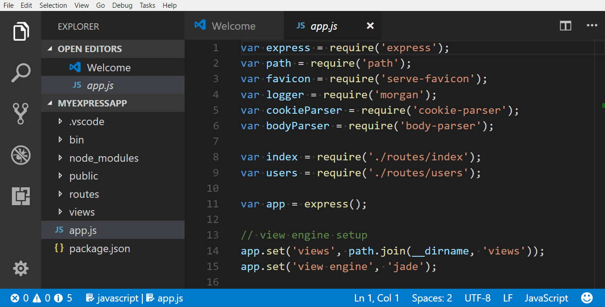

***Figure 3.*** Visual Studio Code IDE

According to Wales (2020), To make the server, application, and data set speak with one another, back-end developers use worker side programming languages like PHP, Ruby, Python, Java, and .Net to assemble an application, and apparatuses like MySQL, Oracle, and SQL Server to discover, save, or change information and serve it back to the client in front-end code. Employment opportunities for back-end engineers regularly likewise call for experience with PHP structures like Zend, Symfony, and CakePHP; experience with form control programming like SVN, CVS, or Git; and involvement in Linux as a turn of events and organization framework. Back-end developers utilize these instruments to make or add to web applications with spotless, versatile, all around recorded code. However, prior to composing that code, they need to work together with business partners to comprehend their specific necessities, at that point make an interpretation of those into specialized prerequisites and concoct the best and proficient answer for designing the innovation.

Cross-stage versatile improvement instruments are acquiring ubiquity on the planet because of their trademark to aggregate the application source code for different upheld OS's. Such devices are essentially relying upon web programming dialects like Hypertext Markup Language (HTML), JavaScript and Falling Style Sheets (CSS) with some local covering code for getting to local Application Program Interfaces (API) like Camera, Contacts; and so on, the application advancement is very simple and efficient with these apparatuses (Palmieri, et al., 2012).

**MongoDB**

MongoDB is a document database that is supposed to be simple to construct and scale. The MongoDB Manual covers important ideas, the query language, operational and administrative considerations, and processes, as well as a thorough reference part. MongoDB also includes powerful features to enhance reliability for mission-critical production databases, such as continuous backups and point-in-time recovery. MongoDB Atlas makes it simple to manage database access (Januzaj, Y., 2015).

MongoDB automated infrastructure provisioning, setup, and deployment, ensuring that teams have the database resources they require when they need them. Minor version upgrades and patches are applied automatically. When the team needs to change the cluster whether to scale out or upgrade - MongoDB Atlas allows them to do it in a few clicks with minimal downtime.

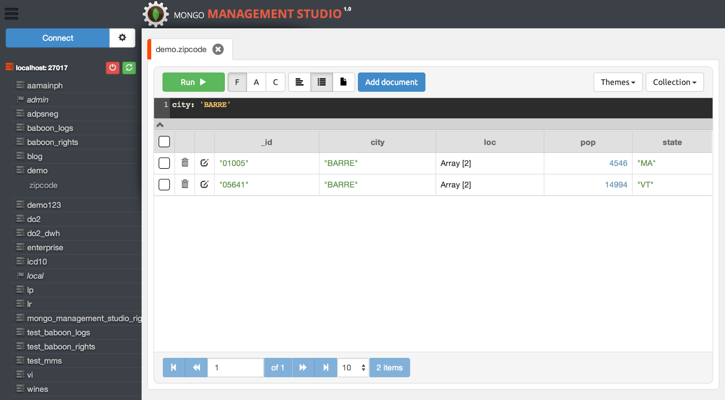

***Figure 4.*** MongoDB Graphical User Interface

API the short for Application Programming Interface is a programming algorithm that is used to communicate with various types of devices or software. API enables a software or device to easily transfer data with one another. API is a set of routines, protocols, and tools for building software applications. An API specifies how software components should interact. Additionally, APIs are used when programming graphical user interface (GUI) components. A good API makes it easier to develop a program by providing all the building blocks. A programmer then puts the blocks together. There are many different types of APIs for operating systems, applications or websites. Windows, for example, has many API sets that are used by system hardware and applications — when you copy and paste text from one application to another, it is the API that allows that to work.

Most operating environments, such as MS-Windows, provide APIs, allowing programmers to write applications consistent with the operating environment. Today, APIs are also specified by websites. For example, Amazon or eBay APIs allow developers to use the existing retail infrastructure to create specialized web stores. Third-party software developers also use Web APIs to create software solutions for end-users (Beal, et al., 2021).

After the development of the system, the researcher will need to test and evaluate the product if it meets the requirements needed and will be useful to those selected barangays. After this, the system can be exported and ready to be used by those barangays.

**Software Evaluation**

According to Perforce (2021), a software quality standard called ISO 25010 with a title “Systems and software engineering - Systems and software Quality Requirements and Evaluation (SQuaRE) - System and software quality models”. Describing characteristics and sub-characteristics of a model for both software product quality and software quality in use together with practical guidance on the use of the quality models.

The foundation of a product quality evaluation system is the quality model. Determining when evaluating properties of a software product to which quality characteristics will be checked (ISO 25000, 2021). Below are the following quality characteristics listed and described.

The product quality model defined in ISO/IEC 25010 comprises the eight quality characteristics of a system is the degree to which the system satisfies the functionality, performance, compatibility, usability, reliability, security, maintainability, and portability as shown in figure below:

***Figure 5***. Software Product Quality  
*Source: https://iso25000.com/index.php/en/iso-25000-standards/iso-25010* 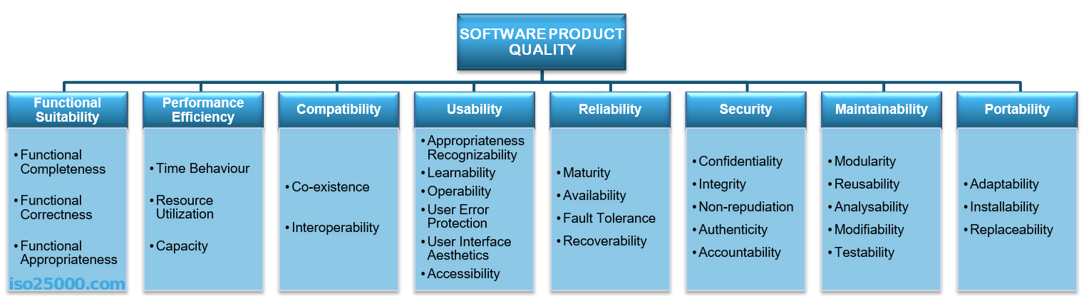

**Functional Suitability** represents the degree to which a product or system provides functions that meet stated and implied needs when used under specified conditions. Functional Suitability is composed of the following sub-characteristics:

• ***Functional completeness***. The degree to which the set of functions covers all the specified tasks and user objectives.

• ***Functional correctness***. The degree to which a product or system provides the correct results with the needed degree of precision.

• ***Functional appropriateness***. The degree to which the functions facilitate the accomplishment of specified tasks and objectives.

**Performance Efficiency** represents the performance relative to the number of resources used under stated conditions. Performance Efficiency is composed of the following sub characteristics:

• ***Time Behavior***. The degree to which the response and processing times and throughput rates of a product or system, when performing its functions, meet requirements.

• ***Resource Utilization***. The degree to which the amounts and types of resources used by a product or system, when performing its functions, meet requirements.

• ***Capacity***. The degree to which the maximum limits of a product or system parameter meet requirements.

**Compatibility** represents the degree to which a product, system or component can exchange information with other products, systems or components, and/or perform its required functions while sharing the same hardware or software environment. Compatibility is composed of the following sub-characteristics:

• ***Co-existence***. The degree to which a product can perform its required functions efficiently while sharing a common environment and resources with other products, without detrimental impact on any other product.

• ***Interoperability***. The degree to which two or more systems, products or components can exchange information and use the information that has been exchanged.

**Usability** represents the degree to which a product or system can be used by specified users to achieve specific goals with effectiveness, efficiency, and satisfaction in a specified context of use. Usability is composed of the following sub-characteristics:

• ***Appropriateness and recognizability***. The degree to which users can recognize whether a product or system is appropriate for their needs.

• ***Learnability***. The degree to which a product or system can be used by specified users to achieve specific goals of learning to use the product or system with effectiveness, efficiency, freedom from risk and satisfaction in a specified context of use.

• ***Operability***. The degree to which a product or system has attributes that make it easy to operate and control.

• ***User error protection***. The degree to which a system protects users against making errors.

• ***User interface aesthetics***. The degree to which a user interface enables pleasing and satisfying interaction for the user.

• ***Accessibility***. The degree to which a product or system can be used by people with the widest range of characteristics and capabilities to achieve a specified goal in a specified context of use.

**Reliability** represents the degree to which a system, product or component performs specific functions under specified conditions for a specified period. Reliability is composed of the following sub-characteristics:

• ***Maturity***. The degree to which a system, product or component meets needs for reliability under normal operation.

• ***Availability***. The degree to which a system, product or component is operational and accessible when required for use.

• ***Fault tolerance***. The degree to which a system, product or component operates as intended despite the presence of hardware or software faults.

• ***Recoverability***. The degree to which, in the event of an interruption or a failure, a product or system can recover the data directly affected and re-establish the desired state of the system.

**Security** represents the degree to which a product or system protects information and data so that persons or other products or systems have the degree of data access appropriate to their types and levels of authorization. Security is composed of the following sub-characteristics:

• ***Confidentiality***. The degree to which a product or system ensures that data are accessible only to those authorized to have access.

• ***Integrity***. The degree to which a system, product or component prevents unauthorized access to, or modification of, computer programs or data.

• ***Non-repudiation***. The degree to which actions or events can be proven to have taken place so that the events or actions cannot be repudiated later.

• ***Accountability***. The degree to which the actions of an entity can be traced uniquely to the entity.

• ***Authenticity***. The degree to which the identity of a subject or resource can be proved the one claimed.

**Maintainability** represents the degree of effectiveness and efficiency with which a product or system can be modified to improve it, correct it or adapt it to changes in an environment, and in requirements. Maintainability is composed of the following sub-characteristics:

• ***Modularity***. The degree to which a system or computer program is composed of discrete components such that a change to one component has minimal impact on other components.

• ***Reusability***. The degree to which an asset can be used in more than one system, or in building other assets.

• ***Analyzability***. The degree of effectiveness and efficiency with which it is possible to assess the impact on a product or system of an intended change to one or more of its parts, or to diagnose a product for deficiencies or causes of failures, or to identify parts to be modified.

• ***Modifiability***. The degree to which a product or system can be effectively and efficiently modified without introducing defects or degrading existing product quality.

• ***Testability***. The degree of effectiveness and efficiency with which test criteria can be established for a system, product or component and tests can be performed to determine whether those criteria have been met.

**Portability** represents the degree of effectiveness and efficiency with which a system, product or component can be transferred from one hardware, software or other operational or usage environment to another. Portability is composed of the following sub-characteristics:

• ***Adaptability***. The degree to which a product or system can effectively and efficiently be adapted for different or evolving hardware, software or other operational or usage environments.

• ***Installability***. The degree of effectiveness and efficiency with which a product or system can be successfully installed and/or uninstalled in a specified environment.

• ***Replaceability***. The degree to which a product can replace another specified software product for the same purpose in the same environment.

*Source: https://iso25000.com/index.php/en/iso-25000-standards/iso-25010*

**Related Studies**

***Electronic profiling of Zinarag, Aparri Cagayan***

The study named Electronic profiling system or “eProfiling system” has a goal to further develop and enhance the existing computerized profiling system of Zinarag, Aparri, and Cagayan. Having to do requirements analysis, it helped the authors in determining various problems that were encountered in the manual operation of profiling. It was conducted at the Barangay in Zinarag to improve their system. The system can do systematic filing of residents profile, barangay profile and housing profile and can provide reports, barangay clearances, certificates and municipal reports (Alonzo et al., 2019). With this study, the researchers will also include a systematic filing for residents and provide reports and certificates, however it will be all conducted online to avoid physical contact and be less time consuming.

***Pampanga’s Barangay Health Information System***

In the study “Pampanga’s Barangay Health Information System (PBHIS): A Decision Support & Health Information System for Rural Health Unit 1”, the study aimed to help provide health services and programs in the rural areas by their organization health unit with the help of decision-support and data analytics system. Furthermore, the system also acts as the platform, which creates stores and makes use of important medical data, which may help the rural health unit with future medical grounds (Estinar et al., 2018). With this study, the researcher will utilize the idea from the authors’ health information system and will use data analytics not just on healthcare related data but also with data coming from different transactions of the barangay.

***Web-based Barangay Information System for Malita, Davao Occidental***

With this study “Web-based Barangay Information System for Malita, Davao Occidental” by M.M Aparici and J.R Ruelan, focused to automate the management of barangay household, commodities, and population, fill barangay data to be accessed on the municipal portal in order to monitor the growth and decline of household, commodities, and population for rapid response, and develop commodity geotagging for barangays. Monitoring the status of its residents makes it easier for them to respond to their needs. (Aparaci & Ruelan, 2018). The researcher will employ the idea from this study by managing most transactions and information from the barangay, which will make creating, reading, updating and deletion of data easier.

## Conceptual Model of the Study

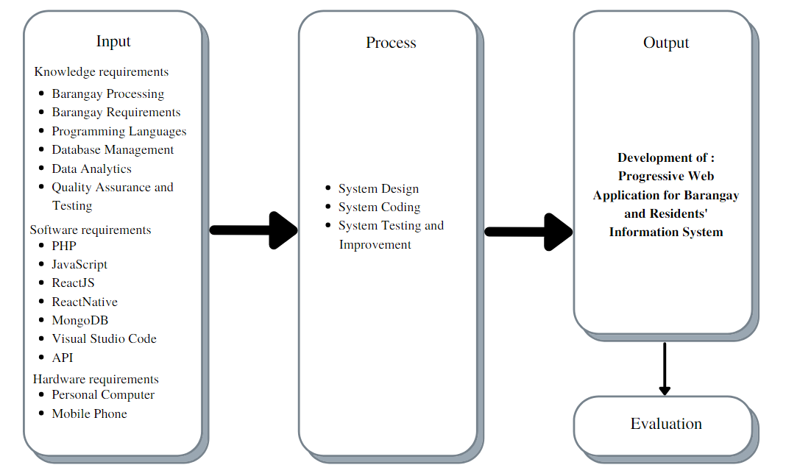 To be able to fulfill the researcher’s aim, Input-Process-Output diagram will be implemented to visualize the conceptual model of the capstone project.

***Figure* 5.** Conceptual Model of the Study

The conceptual model will serve as a blueprint for the project development. The input is split into three categories consisting of knowledge requirements, software requirements and hardware requirements. Knowledge requirements contain the studies, concepts and needed requirements for the project. Software requirements are software technologies such as various programming languages needed to develop the software system. Hardware requirements are devices, such as a personal computer and Mobile phone where the system will be implemented.

The process phase of software development includes system design and analysis, coding, testing, and improvement. To ensure the quality of the software application, ISO 25010 software evaluation instrument tool shall be used to test and evaluate the performance of the system.

Lastly, the output of the study will be the developed Progressive Web Application for Barangay and Residents' Information System

## Operational Definition of Terms

To gain a better understanding of the research, the following terminologies are defined based on their operation:

**CSS or Cascading Style Sheets** refers to simple syntax and uses a number of English keywords to specify the names of various style properties. It will be used to format the layout of [Web pages](https://techterms.com/definition/webpage) of the system.

**GUI or Graphical User Interface** refers to a user interface that includes graphical elements, such as windows, icons and buttons. Is what the users will be seeing or the finished product of the system?

**HTML or Hypertext Markup Language** refers to a standardized system for tagging text files to achieve font, color, graphic, and hyperlink effects on World Wide Web pages.

**IDE** or Integrated Development Environments refers to a standard electronic interface used between a computer motherboard's data paths or bus and the computer's disk storage devices.

**Intellisense** refers to features in Microsoft applications that help the user by making decisions automatically. By analyzing activity patterns, the software can derive the next step without the user having to explicitly state it.

**JavaScript** refers to an object-oriented computer programming language commonly used to create interactive effects within web browsers.

**OS or Operating System** refers to the software that supports a computer's basic functions, such as scheduling tasks, executing applications, and controlling peripherals.

# Chapter 3

**METHODOLOGY**

This chapter includes the project design, project development, operation and testing procedure, and evaluation procedure.

**Project Design**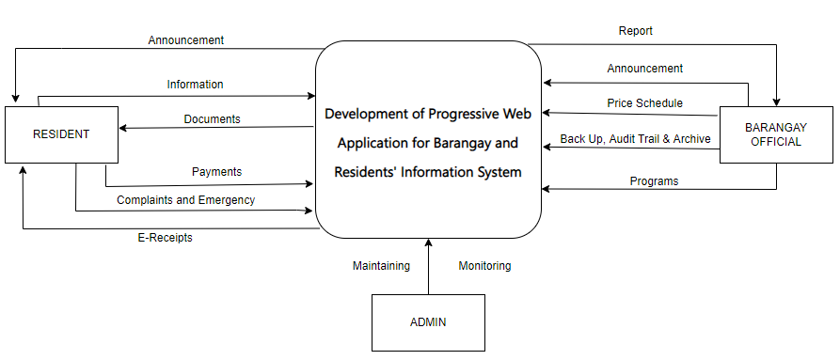

The study will develop a web and mobile-based application, BaRIS, allowing residents, barangay, and higher government (admin) to get their needed documents, collection information, share resources, file and receive reports and other activities that can now be easily done online instead of normal procedure that will take time going to the barangay and maybe endangering the health of these people because of the pandemic. In addition, the study used several modeling tools to analyze the scope of the platform and formulate requirements for it.

***Figure 6.*** Context diagram of the system

**System Design**

The scope of the system will be represented using Context Diagram as depicted in *Figure 6*. The diagram shows the external entities that interact with BaRIS and the network inputs and outputs flowing in and out of the system. The external entities expected to interact with the platform include residents, barangay, and higher government (admin).

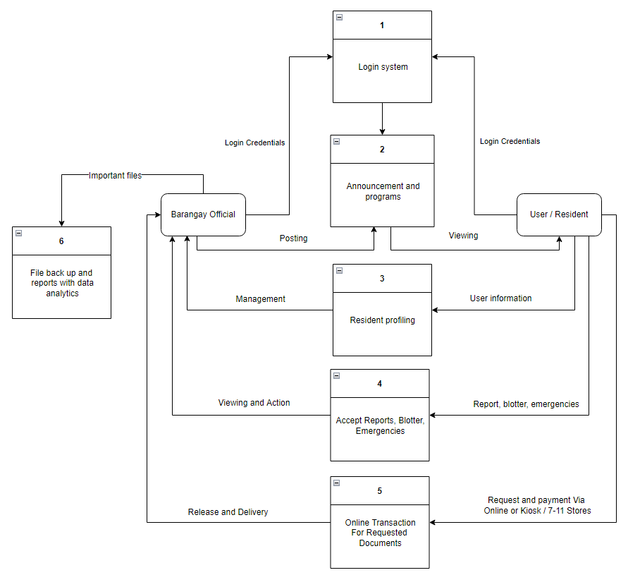

***Figure 7.*** Data Flow Diagram

Based on system requirements in *Figure 7*, the following are the features of the platform designed for all **Users or Residents:**

* Viewing of announcements.
* Fill up their information.
* Report complaints and emergencies.
* Application for needed documents.
* Pay transaction online or via kiosk.
* Receive receipt for transactions.

For **barangay officials:**

* Receiver reports, blotter, and emergencies.
* Post announcements.
* Manage users or residents
* Set price for documents
* Back up, audit trail, and archive data.
* Create programs depending on the need.

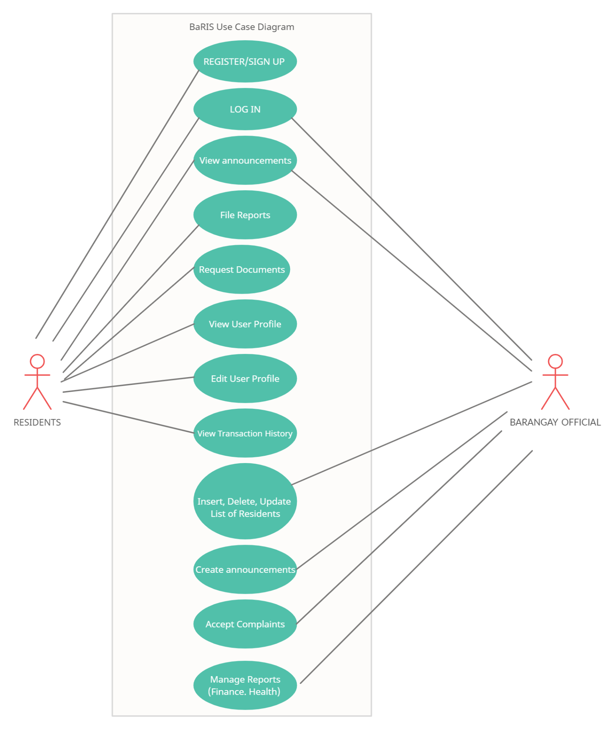

**Figure 8.**Use Case Diagram of the System

*Figure 8* presents the use case diagram of the system showing the different actions in the system and its interaction with the users. The system has 2 external actors and 12 actions that can be performed in the system. The external actors, which are the residents and barangay officials, represent the different user access privilege of the system. Each action on the system can only be accessed with the corresponding privilege.

**Database Design**

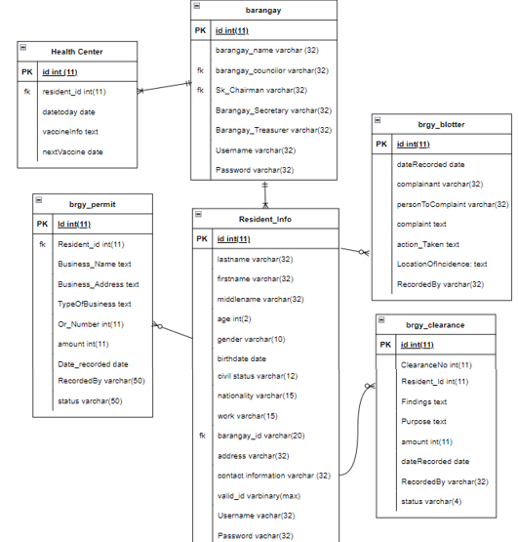

***Figure 9.*** Database Design

*Figure 9* presents the database design of the system. The BaRIS database will store the resident’s information, barangay’s information, councilor’s name, SK councilor’s name, barangay health center information, and other barangay-issued documents such as barangay clearance, business permit, blotter, and disease information.

**Project Development**

The Barangay System will be developed by following the iterative waterfall model approach as shown in *Figure 10*. The model consists of six phases of development, namely: Requirement Analysis, System Design, Implementation or Coding, Testing, Deployment and lastly, Maintenance. Moreover, it features a feedback path for changes or corrections all over the past phases for adjustments and some necessary modifications.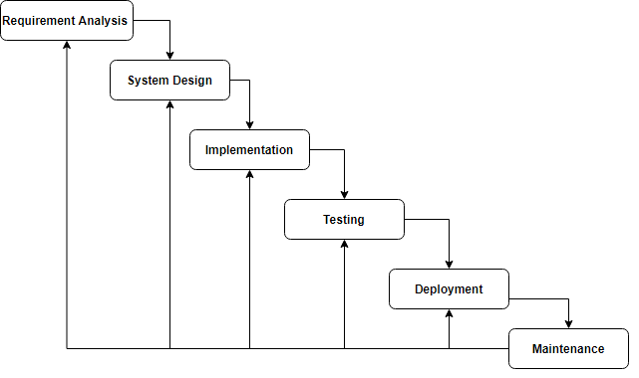

***Figure 10.*** Iterative Waterfall Model

***Requirement Analysis.*** In this phase, the researchers will think of all the possible specifications for the system and outline it properly where all future development can be based. The objectives, goals and what the proposed Barangay Information Management System can do are laid out. The researchers are also looking, analyzing and comparing existing studies, features and projects that can be useful for the proposed system.

***System Design.*** This is the phase where the requirements on the first phase are being studied and prepared by the researchers. It will be focused on technological design requirements such as, programming language, equipment, and information sources that would be helpful for the development of the system. It will include the overall look and functionality of the Barangay System. Feedback path will be accessible if there is more requirement needed.

***Implementation.*** This phase will start by translating or converting all of the design that was specified in the last phase. The Implementation or Coding phase will serve as a vital role in successfully developing the system. The Barangay Information Management System will be developed using PHP for web, JavaScript for the creation of the mobile application, and MongoDB as its Database. An iteration can happen if there will be a problem in analyzing and designing phases.

***Testing.*** The phase where each feature of the system is tested to ensure that everything is working as intended. The researchers will find and disclose problems that must be addressed immediately before going to the next phase. A possible iteration will be done wherever the problem is. It could be in the analysis, designing or implementation phase.

***Deployment.*** This is the phase where the proposed Barangay Information Management system is complete and will be applied to the chosen barangay of the researchers. It would be uploaded on the web and the application can be installed through Google Play Store or on the website itself.

***Maintenance.*** This last phase is where the system should be well maintained in order to keep and provide satisfaction of the users.

**Operation and Testing Procedure**

To ensure the quality of the Barangay Residents and Information System and mobile application, software testing shall be conducted in each software build. The system that will be developed will be tested in terms of functionality, reliability, and portability.

***Functional Testing***shall be performed to check the features or functionalities of BaRIS. This is to ensure that each software component performs the expected output. The following steps shall be taken for each iteration:

1. Distinguish the functions of each software build.
2. Create input data based on the specifications of the function.
3. Identify the output data based on the specifications of the function.
4. Execute the test cases.
5. Compare the actual result from the expected result.
6. Determine the result.
7. Evaluate if the test passes or fails.

*Table 1.*

Test Case Form.

***Reliability Testing*** shall be conducted to examine the performance of BaRIS under given environmental conditions. The following steps shall be taken for each iteration: 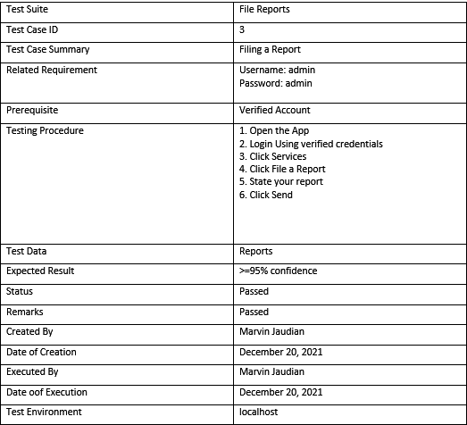

1. Run the BaRIS’ web and mobile application repeatedly in Android environments to determine if the system shall provide the same output and results.
2. Count the total number of failing cases and the total number of cases under consideration.
3. Compute the probability of failure.

***Portability Testing*** shall also be carried out to verify the adaptability, installability, replaceability, and co-existence of both website and mobile application. The following steps shall be taken for each iteration:

1. Run BaRIS on different mobile operating system versions of Android.
2. Run BaRIS on different smartphone devices that run on Android.
3. Run BaRIS on a different laptop or desktop.
4. Run BaRIS on different browsers.

A test case form shall be utilized to record each portability test performed. The results shall be analyzed to determine the effectiveness of BaRIS. *Table 1* shows the test case form.

*Table 2.*Test Case Form.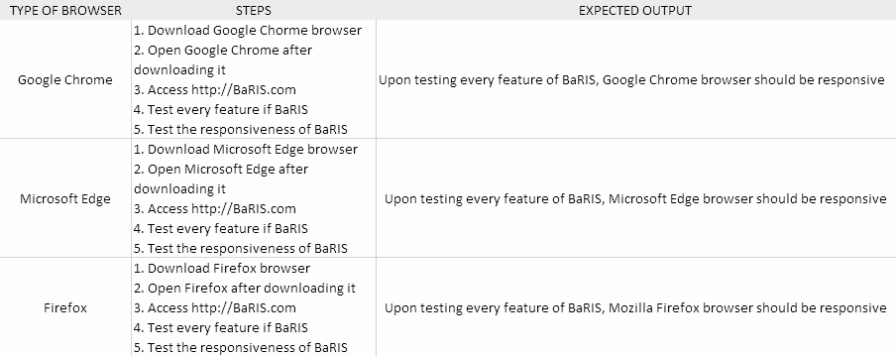

**Evaluation Procedure**

The evaluation instrument that will be used to determine the acceptability of BaRIS will be adopted from the ISO 25010 software quality metrics.

The following procedure will be followed to evaluate the acceptability of the developed BaRIS:

1. The researchers will invite one barangay official for each of the two selected barangays, and two residents for each barangay as well to be the respondents to serve as evaluator of the BaRIS.
2. The objectives of the research shall be discussed and a demonstration shall be conducted to explain the functionalities of the system.
3. Evaluators will be asked to create an account for their respective roles or profile, log it in then browse through all the features of the system.
4. After the project demonstration, the evaluator will be given a questionnaire, rating the system by the standard evaluation criteria of ISO 25010 using a Likert scale rating system as shown in Table 2 where 4 is the highest and 1 is the lowest.

**Table 2.**   
*Likert’s Scale*

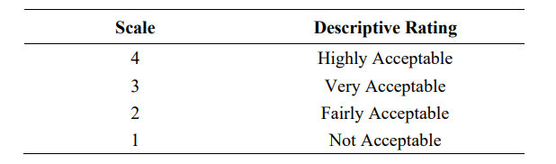

1. The overall mean ratings shall be computed for each criterion based on the collected evaluation.
2. The evaluation results shall be translated into qualitative interpretation using the scale shown in Table 3.

**Table 3.**  
*Scale Range and the Equivalent Descriptive Rating*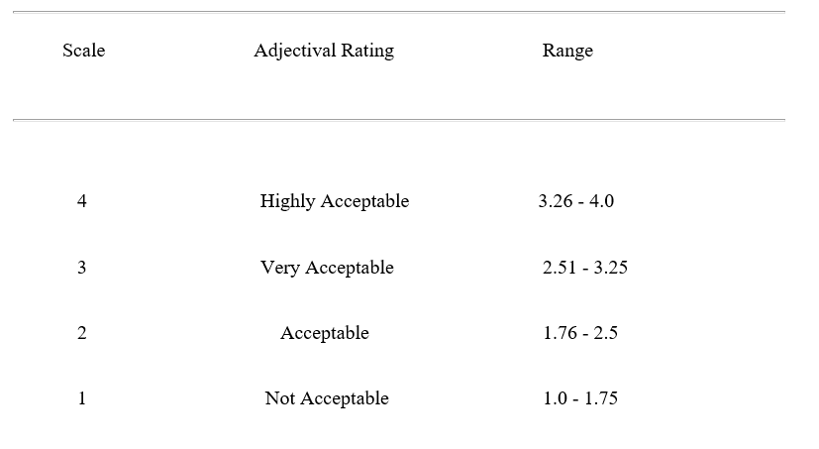

**References:**

Aiim. (2021). *What is information management?* What is Information Management? Retrieved November 19, 2021, from <https://www.aiim.org/what-is-information-management>.

Alonzo, C. P., Alvarez, A. D., Dian, A. J. M., Soriano, R. S., Tabunar, L. G., & Javier, M. B. S. (2019). ELECTRONIC PROFILING OF ZINARAG, APARRI, CAGAYAN. *of INNOVATIONS in INFORMATION and*, *3*(2), 66.

Amatya S., Kurti A. (2014) Cross-Platform Mobile Development: Challenges and Opportunities. Advances in Intelligent Systems and Computing, vol 231. Springer, Heidelberg. Retrieved November 3, 2021 from <https://doi.org/10.1007/978-3-319-01466-1_21>

Aparici, M. M. A., & Ruelan, J. R. J. (2018, May) INFORMATION SYSTEM FOR MALITA, DAVAO OCCIDENTAL”. Retrieved November 21, 2021.

APM (2021). What is Information Management? Retrieved November 7, 2021 from <https://www.apm.org.uk/resources/what-is-project-management/what-is-information-management/>

Arun G. (2017, July 4). *5 advantages of Cross Platform Mobile App Development*. Digital Doughnut. Retrieved November 7, 2021, from <https://www.digitaldoughnut.com/articles/2017/april/5-advantages-of-cross-platform-mob-app-development>

Beal, V., Ledbetter, L., Phipp. J, & Ingalls, S. (2021, July 29). *What is an API (application program interface)?* Webopedia. Retrieved November 4, 2021, from <https://www.webopedia.com/definitions/api/>.

BioMelbourne Network. (2020, January 27). Importance of acceptable use policy – IT Systems & Services. Retrieved November 6, 2021, from <https://biomelbourne.org/importance-of-acceptable-use-policy-it-systems-services/>

Business World. (2018, August 17). *The Barangay System*. Grant Thornton Philippines. Retrieved November 7, 2021, from <https://www.grantthornton.com.ph/insights/articles-and-updates1/opinion/opinion/>.

Chartered Institute of Library and Information Professionals. (2020). Benefits of Information Management. Retrieved November 2021, from <https://www.cilip.org.uk/page/BenefitsfromIM>

Chuprina, R. (2021, November 5). E-Commerce Payment Systems for Business in 2021. Technology Partner for Innovative Companies. Retrieved November 5, 2021, from <https://spd.group/ecommerce-solutions/e-payment-systems/>

Devanesan, J. (2020, July 24). The Philippines is going cashless – finally. Tech Wire Asia. Retrieved November 6, 2021, from <https://techwireasia.com/2020/07/digital-payments-are-finally-soaring-in-the-philippines/>

Estinar, A. O., Grefiel, L. S., Libre, L. H., Lu, L. K., & Tangkeko, M. S. (2018). Pampanga’s Barangay Health Information System (PBHIS): A Decision Support & Health Information System for Rural Health Unit. In *DLSU Research Congress* (pp. 1-6).

Farahat I.S., Tolba A.S., Elhoseny M., Eladrosy W. (2019) Data Security and Challenges in Smart Cities. In: Hassanien A., Elhoseny M., Ahmed S., Singh A. (Eds) Security in Smart Cities: Models, Applications, and Challenges. Lecture Notes in Intelligent Transportation and Infrastructure. Springer, Cham. Retrieved November 6, 2021, from <https://doi.org/10.1007/978-3-030-01560-2_6>

Faris, S. (2019, March 14). *Common problems in management information systems*. Small Business - Chron.com. Retrieved November 19, 2021, from <https://smallbusiness.chron.com/common-problems-management-information-systems-63376.html>.

Ghani, N. A., Hamid, S., Hashem, I. A. T., &amp; Ahmed, E. (2018, August 22). Social Media Big Data Analytics: A survey. Computers in Human Behavior. Retrieved November 7, 2021, from <https://www.sciencedirect.com/science/article/pii/S074756321830414X>.

How to get a barangay certificate of indigency or low income in the Philippines. Archipelago Files. (n.d.). Retrieved November 19, 2021, from http://www.archipelagofiles.com/2017/03/how-to-get-barangay-certificate-of.html.

Interactive Pro. (2021) How Important is Information Management. Retrieved November 15, 2021, from https://www.edology.com/blog/computing-it/how-important-is-information-management/

ISchool (2021, November 15). *What is information management?*. Retrieved November 19, 2021, from <https://ischool.uw.edu/programs/msim/what-is-information-management>.

ISO 25000 Portal. iso25000.com. (n.d.). Retrieved November 30, 2021, from <https://iso25000.com/index.php/en/iso-25000-standards/iso-25010>.

Januzaj, Y., Ajdari, J., & Selimi, B. (2015, July 26). DBMS as a cloud service: Advantages and disadvantages. Retrieved November 7, 2021, from<https://www.sciencedirect.com/science/article/pii/S1877042815038914>

Lorenzo, et al., (2019). Most Encountered Problems in the Barangay. Retrieved from

<https://www.academia.edu/31877668/Most_Encountered_Problems_in_the_Barangay>

Lotha, G., Zelazko, A., Abhinav, V., & Chopra, S. (2019, March 28). *Information system*. Encyclopedia Britannica. Retrieved November 19, 2021, from <https://www.britannica.com/topic/information-system>.

Lyra. (2021, August 3). What is an e-payment system? & How e-payment system works? Lyra India. Retrieved November 6, 2021, from <https://www.lyra.com/in/e-payments/>

M. C. Lucas-Estañ, T. P. Raptis, M. Sepulcre, A. Passarella, C. Regueiro and O. Lazaro, "A software defined hierarchical communication and data management architecture for industry 4.0," 2018 14th Annual Conference on Wireless On-demand Network Systems and Services (WONS), 2018, pp. 37-44, Retrieved November 5, 2021, from [doi: 10.23919/WONS.2018.8311660.](https://orcid.org/0000-0003-4494-5949)

Mercado, I. T., Munaiah, N., & Meneely, A. (2016). The impact of cross-platform development approaches for mobile applications from the user’s perspective. Proceedings of the International Workshop on App Market Analytics - WAMA 2016. Retrieved November 7, 2021, from [doi:10.1145/2993259.2993268](https://dl.acm.org/doi/10.1145/2993259.2993268)

Montealegre, B., Francis, Bolilia, M. D. (2021, April 22). *How to get Barangay Clearance*. Philippine Clearances. Retrieved November 19, 2021, from https://philippineclearances.com/barangay-clearance/.

Padillio, A. M. (2019, July 22). Is the Philippines ready to go cashless? iMoney.ph.

Retrieved October 1, 2021, from <https://www.imoney.ph/articles/cashless-paymentphilippines/>.

Palmieri, M., Singh, I., Cicchetti, A. (2012). Comparison of cross-platform mobile development tools. Retrieved November 7, 2021 from<https://ieeexplore.ieee.org/abstract/document/6376023>

Pedamkar, P. (2021). *What is visual studio code?: Features and advantages: Scope & Career*. Retrieved November 4, 2021, from [https://www.educba.com/what-is-visual-studio-code/](https://www.educba.com/what-is-visual-studio-code/.)

Perforce (2021). What is ISO 25010: Retrieve November 30, 2021 from

<https://www.perforce.com/blog/qac/what-is-iso-25010>

Putatan procedure - city government of Muntinlupa. (n.d.). Retrieved November 19, 2021, from https://muntinlupacity.gov.ph/wp-content/uploads/2017/04/putatan-procedure.pdf.

Regional Safe Space Network. (2019).what-is-information-management Retrieved November 21,2021, from <https://rssn-americas.org/what-is-information-management>

Rubrik. (n.d.). The Importance of Data Backup and Recovery. Retrieved October 1,

2021, from <https://www.rubrik.com/insights/the-importance-of-data-backup-andrecovery>

Runkler, T. A. (2012). *Data Analytics | SpringerLink*. Data Analytics | SpringerLInk. Retrieved November 21, 2021, from <https://link.springer.com/book/10.1007%2F978-3-8348-2589-6>.

Samonte, M. J. C., Arganza, J. M. Q., Aurelio, C. M. E., & Gonzales, P. D. A. (2019,

March). E-Complaint: An Analytical Crowdsourcing Mobile Application for Community

Peace and Order System. In Proceedings of the 2019 2nd International Conference

on Information Science and Systems (pp. 105-109).

Savillo, D., & Ruaya, R. (2021, September 7). Here’s why you should have a digital wallet today. INQUIRER.Net. Retrieved November 6, 2021, from <https://cebudailynews.inquirer.net/398573/heres-why-you-should-have-a-digital-wallet-today>

Simplilearn. (2021, November 15). *What is data analysis? types, methods and techniques: Simplilearn*. Simplilearn.com. Retrieved November 21, 2021, from <https://www.simplilearn.com/data-analysis-methods-process-types-article.>

Stiltner, M. (2021, March 17). The Philippines Top Four Payment Methods. Rapyd. Retrieved November 3, 2021, from <https://www.rapyd.net/blog/philippines-payment-methods/>

Suria International Services (2020, October 26) Key business benefits of cross-platform apps you need to know. Retrieved November 6, 2021, from <https://www.suriainternational.com/benefits-of-cross-platform-app-development/>

Techopedia. (2017, January 24). *What is Information Management (IM)? - definition from Techopedia*. Techopedia.com. Retrieved November 19, 2021, from <https://www.techopedia.com/definition/20012/information-management-im>.

Teclogiq. (2019, May 11). How to build cross platform mobile apps? Medium. Retrieved November 21, 2021, from [How to Build Cross Platform Mobile Apps? | by Teclogiq | Medium](https://teclogiqs.medium.com/how-to-build-cross-platform-mobile-apps-77515baee2ab)

The Local Government Code of the Philippines. (n.d.). Retrieved November 7, 2021, from <https://dilg.gov.ph/PDF_File/reports_resources/dilg-reports-resources-2016120_5e0bb28e41.pdf>

Urban barangay | Philippine Statistics Authority - psa.gov.ph. (n.d.). Retrieved November 7, 2021, from <https://psa.gov.ph/content/urban-barangay-1>.

Wales, M. (2020, December 27). Front-end vs back-end vs full stack web developers. Retrieved November 3, 2021, from <https://www.udacity.com/blog/2020/12/front-end-vs-back-end-vs-full-stack-web-developers.html#:~:text=The%20front%20end%20of%20a,SKILLS%20AND%20TOOLS>

What is data analytics? - 4 ways to use data analytics. Lotame. (2021, May 7).

Retrieved October 1, 2021, from <https://www.lotame.com/what-is-data-analytics/>.

Wróbel-Konior, S. (2020, February 5). What Is an E-payment System? SecurionPay - Payment Platform With Advanced Technology. Retrieved November 6, 2021, from <https://securionpay.com/blog/e-payment-system/>

Zbick, J. Nake, I., Jansen, M., Milrad, M.(2014, November 01). Mlearn4Web: A web-based framework to design and deploy cross-platform mobile applications. Retrieved November 7, 2021, from <https://dl.acm.org/doi/abs/10.1145/2677972.2678007>

Zwass, V. (2020).*Journal of Management Information Systems. Retrieved November 15, 2021, from* [*https://www.britannica.com/contributor/Vladimir-Zwass/4614*](https://www.britannica.com/contributor/Vladimir-Zwass/4614)